Who can request an account?
The AT Exchange website is open to the public and is geared to those in need of acquiring or recycling assistive equipment.

Step 1: Where do I request a new account?
Go to http://www.exchange.abilitytools.org and on the left of the page, under the Login section click on "Request a New Account."
Figure 1: Graphic indicating login and request New Account section.

Step 2: How do I request a new account?
Simply fill out the form as shown and agree to the terms listed. Passwords must be no less than six characters and must contain at least one alpha character and one numeric character. Fields marked with a (arrow symbol) are required.
Figure 2: Graphic showing red arrows indicating a required field.

Step 3: Activating your account
After you press ‘Create Account’, an email is sent to the address you provided. Be sure to check your Junk/Spam folder. In this email is a link to activate your account. Make sure you have received the email (Subject: The AT Exchange Account Activation) and activated your account. Then be sure to enter your full email address and password when logging on.
Figure 3: Graphic showing a sample confirmation e-mail.

Step 4: Account Verification
After activating your account, you will be directed to the AT Exchange and this message will appear: "Thank you for activating your AT Exchange account! Please click here to login."

How do I find an item?
To search for an item, you can use a Simple Search or an Advanced Search choosing various factors such as location or free/loan.

Simple Search
Figure 4: Graphic indicating simple search field and advanced search field.
- Enter a keyword or phrase in the item search box.
- Choose a Category from drop-down menu list.

Advanced Search
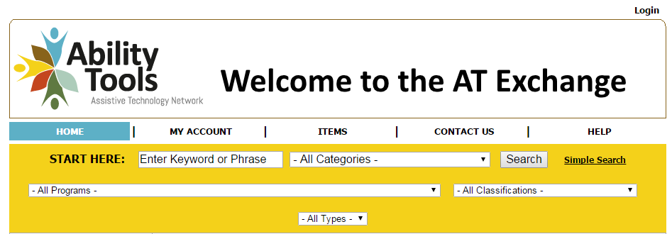
Figure 5: Graphic showing the expanded advanced search field.
- Click Advanced Search:
Optional factors for advanced search include:
Enter a keyword or phrase in the item search box.
- Choose a Category from the drop-down menu list.
- Choose a Program / City
- Choose a Classification from the drop down menu list.
- Choose a Type (Loan, Wanted, Sale, Free, Demo) from the All Types drop-down list.

AblilityTools.org
Find devices for sale or free:
https://exchange.abilitytools.org
(800) 390-2699

